4205843 - Note List Visibility Enhancement
Note List Visibility Enhancement (Epic 4205843)1. Customer Problemcannot see enough of note content without extra clicks, reducing productivity and missing context.
2. Customer Researchreferences CSA as example and requests expanded text in preview, list screen, and add-in.
3. Our SolutionExpandable, readable note text under subject row in grids and preview pane.
- Consistent rendering across EM and Office add-in.
Dependencies: FE components, add-in UI, notes API.
4. Product MetricsNotes opened to view full text: -40%.
- Time on task when triaging notes: -25%.
- Consistency defects across surfaces: 0 P1s.
Appendix: Child Features4231144 Notes List Grid Enhancement
- 4237571 Expanded Notes Preview Pane on the workpapers tab
- 4237576 MS Office Add-in Notes Enhancement
Appendix: LinksHYPERLINK "https://dev.azure.com/tr-tax/TaxProf/_workitems/edit/4205843"Open Epic 4205843

Appendix: Quick prototype
Figure: PDF page 1
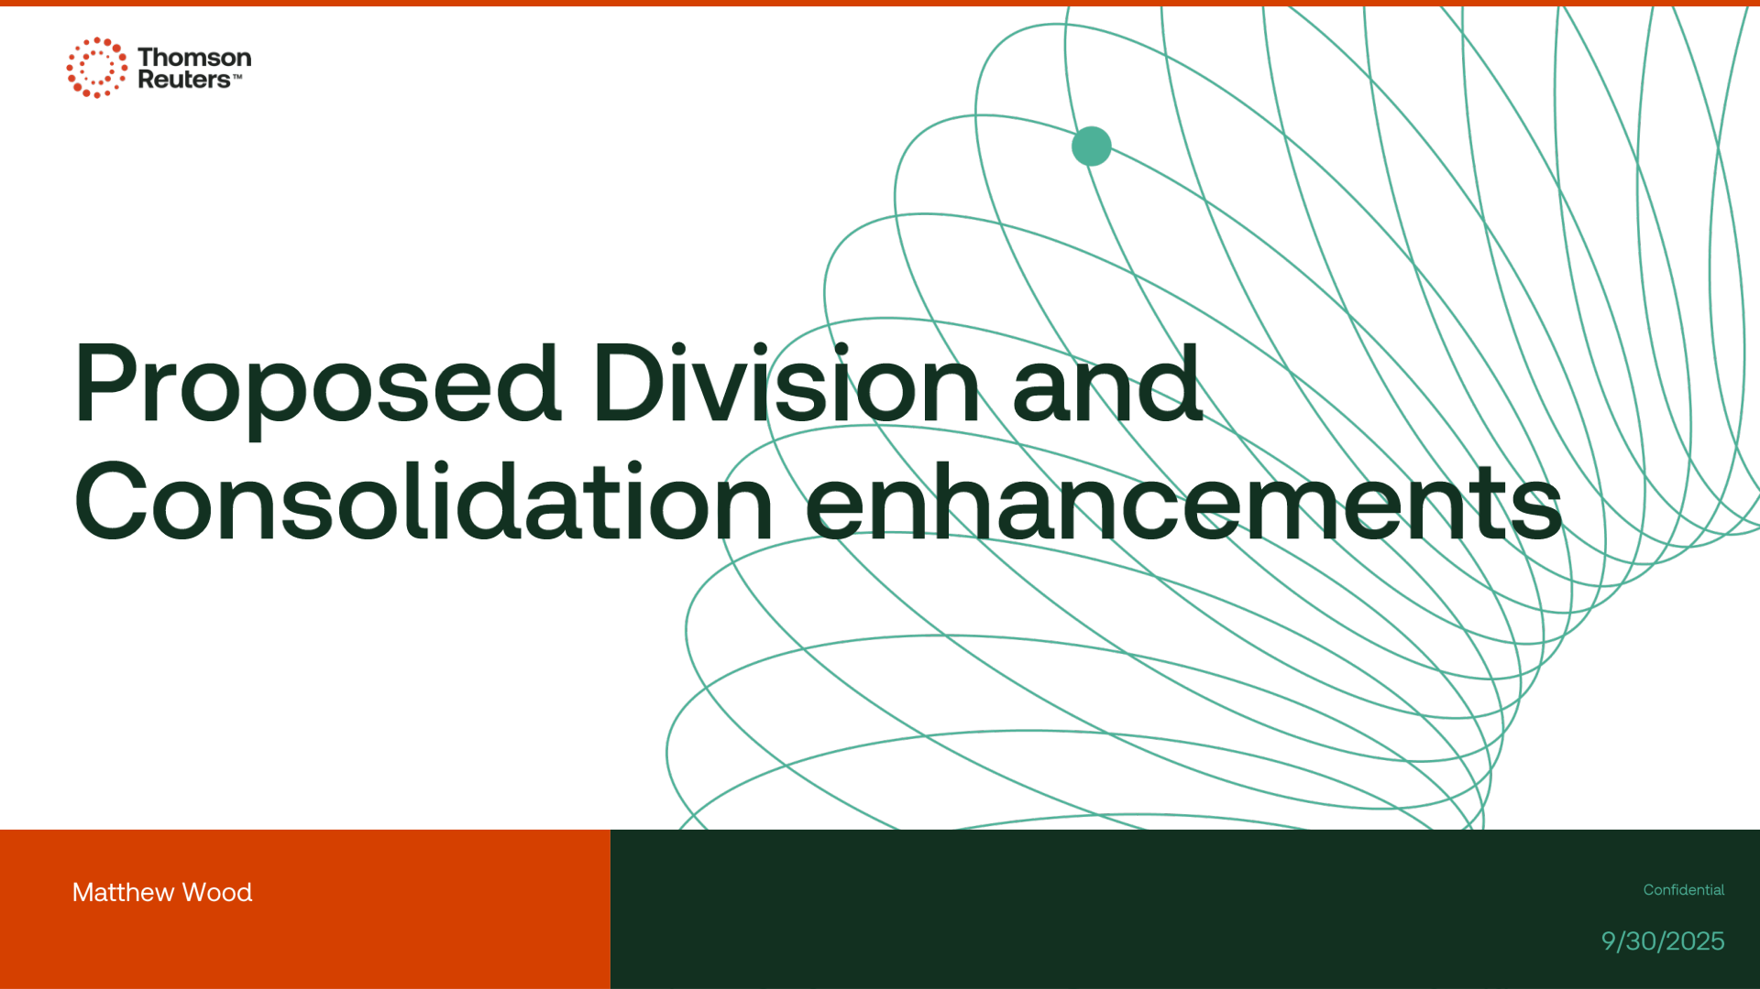

Appendix: Links
ADO Epic Link: https://dev.azure.com/tr-tax/TaxProf/_workitems/edit/4205843

